

PHYSICS MODELLING

MATHEMATICAL EQUATIONS

Zainab Hussein | ECE 492 | February 19, 2017

1. Background:

The motor and motor controller used for the electric car project is synonymous to a black box taking in electric inputs of current and voltage and give out mechanical outputs of torque and rpm shown in figure 1. To better understand what exactly happens within this system, two characterizations, static and dynamic are necessary to observe the behavior when the car motor is moving in constant speed versus with addition of acceleration. The static characterization models the forces involved in this black box to result in uniform speed while dynamic characterization models the static model with an additional acceleration force in play. Details of the models are discussed in the section 4.

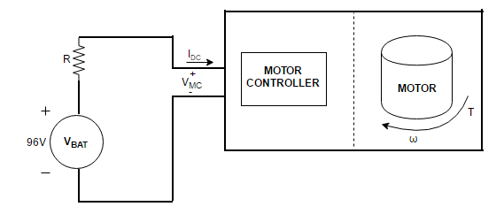

Figure 1 High level representation of the motor and motor controller I/O

$V_{MC}=V_{BAT}-I_{DC}R$ Eq.1

Where VMC is motor controller voltage, VBAT is battery voltage, IDC is supply current, R is internal resistance of battery pack, T is torque and ω is motor speed in rpm in equation 1.

# Introduction

The objective of this report is to demonstrate an understanding of the theory behind how the motor and motor controller works internally through analyzing how the electrical inputs interact with the mechanical outputs of this black box. Proper understanding of the static and dynamic characterization models is essential to model cruise control of the car later. The understanding of the I/O relationship of this black box will enable proper estimation of system heat loss from the system power loss that is the difference of the electrical power in and the mechanical power out of the system. Also, this report aims to examine the cascade relations between when the car pedal is pressed to the resulting motor torque, motor rpm and car speed. All these objectives are to be presented in the form of mathematical equation derivations.

# Methods

The mathematical derivations discussed in the results section are based on an analysis of dynamic and static experiments conducted by students in Spring 2016, whose reports and excel data spreadsheets cited in the reference section are used as sources of data.

# Static characterization report

Characterize and understand the behavior of the Electric Vehicle motor operating at steady state conditions with an aim of relating I/O of the motor and controller system by either equation or lookup table.

# Dynamic characterization report

Characterize and understand the behavior of the Electric Vehicle motor operating in dynamic conditions with an aim of relating I/O of the motor and controller system by either equation or lookup table.

# Mathematical Equation Derivations

# Static Characterization Model

The static characterization models the sum of forces acting on a steady state behaving motor and motor controller system as shown in figure 2. The result of this torque equation characterization results in a mathematical equation for the rpm of the system in steady state.

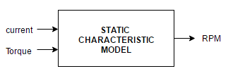

Figure 2 High level static characterization model

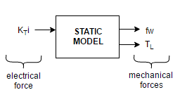

Figure 3 Forces affecting the steady state of motor and motor controller system

∑Forces affecting a static model of the motor and motor controller have a starting point of this important torque equation which models a Newton’s second law of motion, stating that the net force on an object is equal to the product of mass of the object and its acceleration shown in Eq.2:

$F=Ma$ Eq.2

Where F is, force acting on a body, M is the mass of the body and a is acceleration of the body in Eq. 2.

$T_{L}=K_{T}i-fω$ Eq.3

Where TL is load torque, ω is motor speed in rpm, KT is torque constant, *i* is supply current and f is friction coefficient in equation 3.

To find the constant values of KT and f, figure 8 in cited static characterization report of a graph of zero rpm current versus torque, a fit presents a straight-line equation below representing a direct proportionality of current and torque:

$i=2.3226E-1T_{L}$ Eq.4

At zero rpm above, the ω component of equation 3 is removed and results in:

$T_{L}=K_{T}i$ Eq.5

When Eq.4 is plugged into Eq.5, KT is 4.3055.

The remaining unknown constant is f, which is made the subject of Eq.3 in Eq.6 below and calculated from experimental data for torque, current and rpm. These are the same data used to plot graph shown in figure 5 of RPM versus current at various torque settings. The range of friction coefficient values is graphed against TL resulting to a straight-line fit Eq.7.

$f=\frac{K_{T}i}{ω}-\frac{T_{L}}{ω}$ Eq.6

$f=(5.6000E-2{)T}_{L}$ Eq.7

Plugging Eq.6 into 5 results in the motor speed in rpm equation that models the static characterization in Eq.8.

$ω=\frac{(7.6875E+2)i}{T_{L}}-(1.7857E+2)$ Eq.8

## Dynamic characterization model

Dynamic characterization models the static model with an additional acceleration force in play.

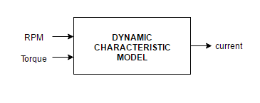

Figure 4 High level dynamic characterization model

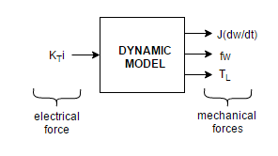

Figure 5 Forces affecting the dynamic state of motor and motor controller system.

∑Forces affecting a dynamic model of the motor and motor controller have a starting point of this important torque equation which models a basic force equation shown in Eq.3:

$T_{L}=K_{T}i-fω-\frac{Jdω}{dt}$ Eq.9

Where TL is load torque, ω is motor speed in rpm, KT is torque constant, *i* is supply current, f is friction coefficient and J is moment of inertia in equation 8.

All the coefficients are the same as used in the previous equations, thus, the only unknown for equation 9 is J. The cited dynamic characterization uses experimental data of the other parameters of the equation 9 to calculate for J. However, J can be calculated from the physical geometry of the rotating motor shaft using equation 10.

$J=\frac{1}{2}MR^{2}$ Eq.10

Where M is mass of the motor shaft and R is the radius of its cross-section area. [NEED TO MEASURE THESE AND CALCULATE TO COMPARE TO EXPERIMENTALLY CALCULATED ONE]

Experimental calculation of J in the dynamic characteristic report was done in figure 5 and the mean J of 0.006 chosen. When Eq.8 and J are substituted in Eq.9, solving the differential equation in Eq.9, Eq.11 which is the current equation that models the dynamic characterization.

Eq.11

* 1. Cascade pedal press relation to:

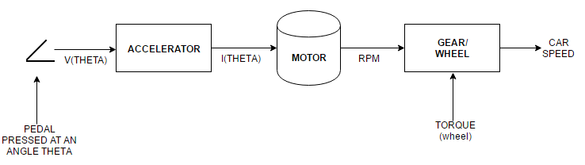

Figure 6 Cascade relation of pedal press (input voltage) to rpm, torque, input current and car speed

* + 1. Supply current into the black box

Figure 7 which is a plot of supply current versus % throttle shows a relatively high R2 fit for the graph showing a direct proportionality relation of current and the input voltage. This relationship is expected to follow Ohms law, which is consistent in eq.12

Eq.12

* + 1. RPM

Figure 8 which is a plot of rpm versus % throttle shows a relatively high R2 fit for the graph showing a direct proportionality relation of motor speed in rpm and the input voltage. This relationship is expected because for a fixed load, the speed of the motor increases with applied input voltage which is consistent in eq.13

Eq.13

* + 1. Torque

Figure 9 which is a plot of torque versus % throttle shows a high R2 fit for the graph showing a direct proportionality relation of torque and the input voltage. This relationship is expected because for a fixed load, the load torque variable increases with applied input voltage which is consistent in eq.14

Eq.14

* + 1. Car speed
  1. Power dynamic relations

A model of system power loss from the motor controller and motor system is through relating the input power and the output power. For an ideal system, the electrical and mechanical power should be equivalent to suggest there is no loss. However, our system is not ideal, therefore, this loss surfaces as heat loss from the system.

$P_{LOSS}=P_{IN}-P_{OUT}=V_{MC}.I_{DC}-\frac{T_{L}ω}{2π}$ Eq.15

where PLOSS is, the power lost as heat in the motor and controller system, PIN is the electrical power into the motor and controller system, POUT is the mechanical power coming out of the motor and controller system, VMC is the motor controller voltage, IDC is the direct current into the motor controller, TL is load torque and ω is speed of the motor in rpm in eq.15.

# Additional Graphs complementing the derivations in section 4.